Seabreeze Pest Control Inc.
Issue 1, Volume 1

October Newsletter

In this Issue
Welcome & Thank You 1
Updates 1
Specials & Discounts 1
Fall News 2
About us
Seabreeze Pest Control Inc. is a family owned and operated lawn and pest control business. It was founded by Brian C., our current owner, in 1993 as a lawn and landscape company and soon blossomed into the pest control industry. Since it began Seabreeze has been expanding in both popularity and customer satisfaction. Currently servicing Pasco, Hernando, Pinellas, and Hillsborough Counties we are aiming to provide more services outside of Hudson and more into Trinity, Land O’Lakes, New Port Richey and surrounding areas.
Lawn treatments are also part of Seabreeze’s services. Lawn aeration and fertilizers are important to make old lawns remain vibrant and healthy. Keeping a healthy lawn is vital to property values, so don’t forget this amazing service right at your fingertips.
For more info visit our website hosted by Wix.com.
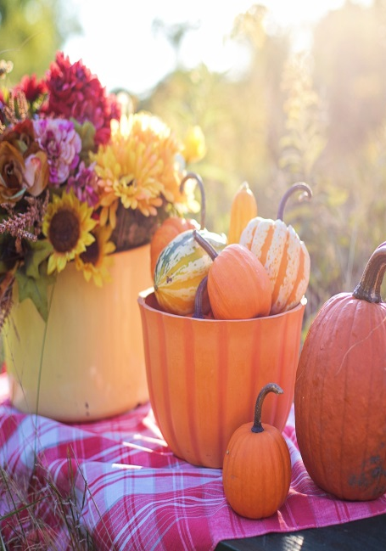
Welcome!
Hello and welcome to our first ever newsletter. Here we will be updating you on current specials, new information, tips, interviews, and more. Be sure to let us know if there is anything you would like us to mention in the next issue by using our contact info at the bottom of the newsletter. We appreciate your comments so feel free to let us know on our social media. Without further ado….the October Issue!

Updates
We are currently updating our website and have added new features to help serve you. We have added:
- Kids activities
- Informative blog
- Specials page
- New design
- Chat function
Specials and Discounts
As usual we offer discounts for seniors (65+), first responder personnel, officers, military, and Veterans as a way to say thank you for everything you do for our country. We are also currently running a raffle for a $50.00 visa gift card for our referral program. This doesn’t just mean you have to spend it on us- you can spend it wherever you like. Here’s how it works:
- Refer a friend, neighbor, or family member
- Tell them to mention your name
- And….when they use our services you get one ticket added to the raffle

There is no Limit to entries!
Lawn Tips for Fall
Don’t forget your lawn won’t be growing as much due to less rain fall. No need to worry about mowing every other day, now you can use your time to grow that vegetable garden you’ve been wanting, spend time with family, or just relax.
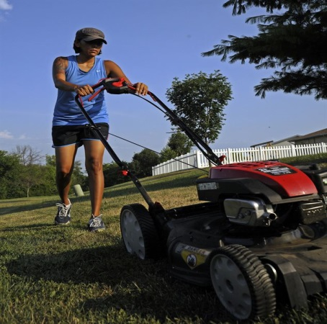
Events Calendar
Looking for Events for October? Visit your counties website by following the links.
Pasco County: https://www.pascocountyfl.net/calendar.aspx
Hernando County: http://www.hernandocounty.us/departments/departments-n-z/parks-and-recreation/events
Pinellas County: http://www.pinellascounty.org/Events/default.htm
Hillsborough County: http://business.hillsboroughchamber.com/events/calendar
Things to Remember
Halloween is on Wednesday October 31st this year.
Many religious observances this month.
Fall News
Say Goodbye to Summer and Hello to Fall. This year Fall started on September 23rd, could you tell? I bet some of you Fall Fanatics could. Fanatic or not, there are plenty of signs that fall is in the air- and there are so many things to do. Since the weather is cooling down many outdoor activities are a MUST for this season. You can go on a walk, hike, ride a bike, attend a festival, pumpkin carving our favorite! Don’t forget that pumpkin spice everything is out now so grab a latte or even a slice of pie!
Even holidays are exciting this season. The most notable being All Hallows Eve, otherwise known as Halloween. This is a great family holiday for children, parents, grandparents and pets. Everyone gets the chance to dress up and be whoever they want.
**Don’t forget it’s the best time for our Core Aeration Services! Call Now!
Low-Fat Dairy-Free Pumpkin Pie Recipe

Pumpkin pie is a must for this time of year so we’ve found a recipe that fits a healthy lifestyle but still tastes amazing!

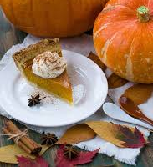
Ingredients:
- Pie Crust (Bought/Made)
- 2 ¼ cup pumpkin puree
- ½ cup maple syrup
- ¼ cup non-dairy milk
- 1 tbp Coconut oil
- 1 Tsp Vanilla Extract
- 3 Tbp cornstarch (or 1 egg)
- 2 tsp of pumpkin pie spice

Directions: Preheat oven to 350°F. Combine all ingredients and place in pie crust. Bake for 1 hour. Let cool for at least 2 hours before enjoying. Makes 1- 9x9 inch pie.

