Seabreeze Pest Control Inc.
Issue 2, Volume 1

November Newsletter

In this Issue
Welcome, In this issue 1
Updates 1
Specials & Discounts 1
Tips & About Owner 2
Recipe & Reference 3
Frequently Asked Questions (FAQs)
Below are some questions that many clients have asked in the past in hopes to help clear up any gaps you may have about our services.
- Do I need lawn services every month?

We typically service Feb-Nov. This would be the time of the year where insects and disease pressure is at its highest. Dec.- Jan. are our dormant months and tend to need less attention.

- How long do I need pest control services?

You will always want external pest control services. Indoors you’ll want a treatment plan for inside your home. In order to keep pests out its best to always to be treated especially in Florida’s environment.
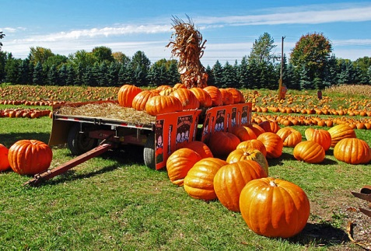
Welcome!
Thank you for subscribing to our newsletter. We would like to first apologize for the mix-up in last month’s newsletter. The discounts page is now updated with more information about our services. All we need is a phone call and we will gladly discount your account before services.

Updates
The Winner to our September Raffle was Edith M. Congratulations.
We are running a 25% off special for all first-time lawn treatments!
Updates to our website and have added to help better serve you. We have added:
- Homepage
- Air Potato Beetle Blog Post
- What is Potash? Blog post.
- Lawn Care Page
If there is any information you’d like to know more about email us at
Specials and Discounts
As usual we offer discounts for seniors (65+), first responder personnel, officers, military, and Veterans. We are also currently running a raffle every month for a $50.00 Visa Gift card for Referrals. (Restrictions apply).
It’s Simple! How to Enter:
- Refer a new client
- Tell them to let us know they were referred by you
For more info visit our website hosted by Wix.com.
- Do I need to worry about rodents in the cooler months?

Rodent like to keep warm so anytime it starts to get cold, even in Fall, there is a chance that you’ll have them in your house. In these colder months you’ll want to be protected. They are more prevalent in cooler months, but they will enter your home at any time during the year.
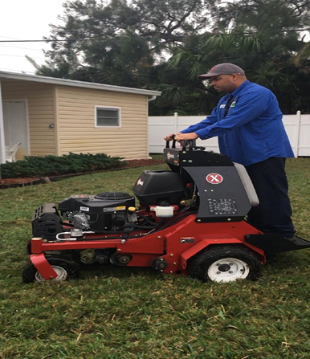
Events Calendar
Pasco County: https://www.pascocountyfl.net/calendar.aspx
Hernando County: http://www.hernandocounty.us/departments/departments-n-z/parks-and-recreation/events
Pinellas County: http://www.pinellascounty.org/Events/default.htm
Hillsborough County: http://business.hillsboroughchamber.com/events/calendar
Things to Remember
Thanksgiving is on November 22 this year.
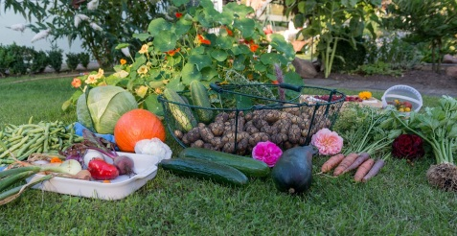
November Gardening in Florida

Although there isn’t a huge temperature drops, like in other states, a fall vegetable garden is still possible in this temperamental state. Here are a few tips before you start a fall garden:
- Pick up a farmer’s almanac for 2018
- Choose vegetables you think you’ll eat
- Plan out where the best area is for your plot
- Test your soil
- Ask any friends or family about what grew best for them
An almanac is at the top of the list. If you’re unsure what that is here’s an easy explanation. A Farmer’s Almanac is a calendar for weather patterns. It shows the best time to plant fruits and vegetables and other relevant information pertaining to your garden.
About the Owner: Brian C.
Seabreeze Pest Control was started by the current owner Brian Cummings in the 1980’s. He is originally from New York, but decided to move to Florida in 1986 to pursue his goal of opening his own business. He is married to Patty c., who runs the office at the company, and they have two children and two dogs together.
Interviewer: What do you like most about your Job?
Brian : I love that everything changes. You always learn something new whether it be of certain insects, lawn treatment, or rodents there is always improvements.
Interviewer: What is the worst pest in your opinion, and why?
Brian: German roaches and fleas. Roaches just cause so many problem like respiratory issues and fleas just get everywhere. Both can be treated but are really just a nuisance to everyone.
Lawn Tips for November
Even Florida gets cooler weather and plants are very sensitive to this change. Here are a few tips to help with the changing of temperature to help keep your lawn alive.
For Plants & Lawn :

- Water less often, around once every two weeks.

Only for Plants:

- Bring any potted plants indoors or place under a porch or covering.

- Cover your plants with cloth when the weather hits freezing temperatures. Never use tarp or plastic material.

- Remove cloth covers when sun comes up.

For Your Lawn:

- Cut your St. Augustine grass to 3.5 to 5 inches, or whatever length your specific grass should be kept, to protect against frost.

What’s in the Next Issue?

The December issue will be featuring Rodents and how to prevent them from entering your home.

Have a Great Holiday Season and we’ll be sending out our next issue in the beginning of December.
Cranberry-Apple Chutney Recipe

Instead of making the same old cranberry sauce try this chutney for a twist on the original thanksgiving side. It’ll add flare and extra flavor to your feast. It’s a little more complicated but well worth it!

Ingredients:
- 12 oz Frozen Cranberry  - 2 Green Apples, Peeled  - 1 Medium Onion, Sliced  - ½ Cup Brown Sugar  - 1 ¼ Cup Cane Sugar  - ¼ cup Apple Cider Vinegar  - 1/8 Tsp All Spice | - 1/8 Tsp Clove  - 1 Tsp Cinnamon  - ¼ Tsp Salt  - ½ Cup Water  - ½ Cup Chopped Walnuts (Optional)
Directions:

Sautee onions on medium in butter or oil until caramelized and set aside. Then add water, sugar, and cranberries to pan. Heat on medium until all sugar is dissolved. Let simmer for 4 minutes and add remaining ingredients except for walnuts. Let simmer until everything is combined and dissolved. Turn off heat and fold in walnuts. Enjoy.

**Spices and sugar can be changed for personal preference

References for more information

Article for Vegetable Gardening: https://www.tampabay.com/things-to-do/food/cooking/yes-you-can-grow-a-garden-of-vegetables-in-florida-heres-how/2242565

Farmer’s Almanac Info Online: https://www.farmersalmanac.com/

For More Information Visit our Blog or follow us on social media like Facebook or twitter.

